**Introduction:**

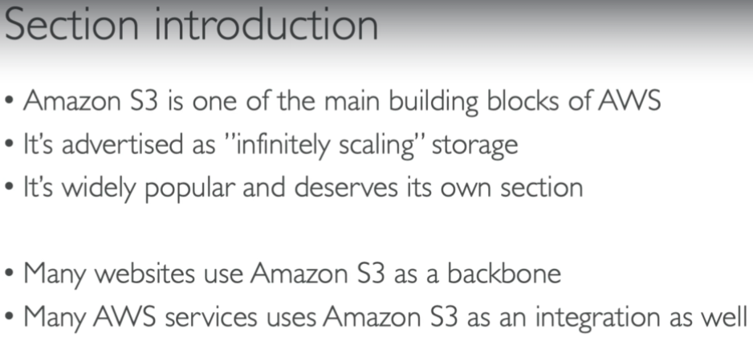

* S3 is very cheap

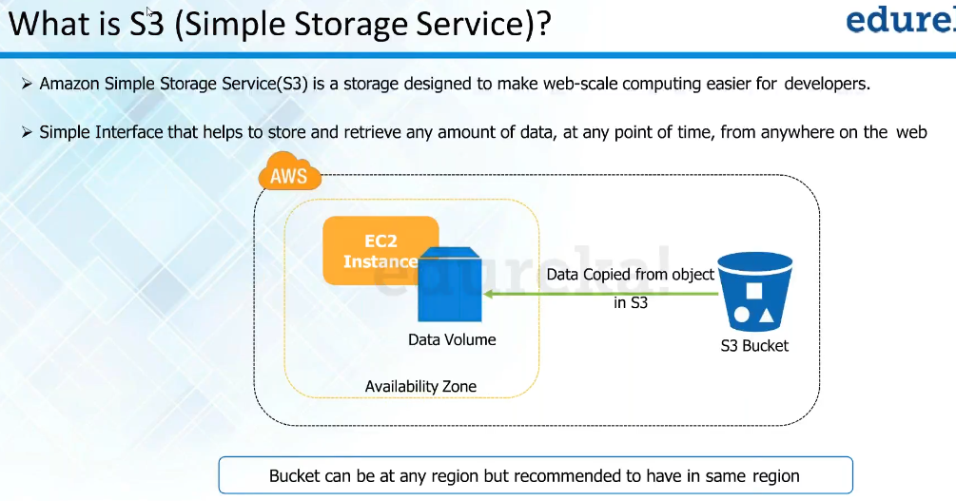

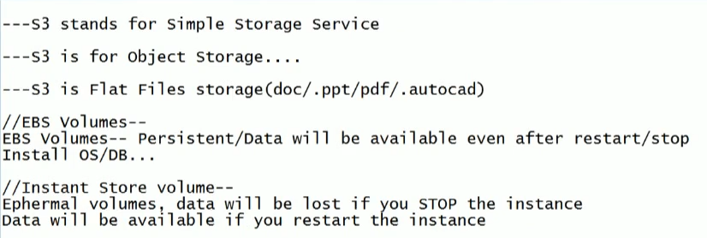

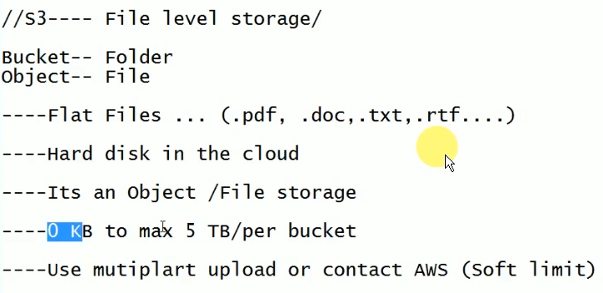

* Multipart upload is to divide the object into to smaller units and helps easy uploading of data
* We get unlimited storage of s3

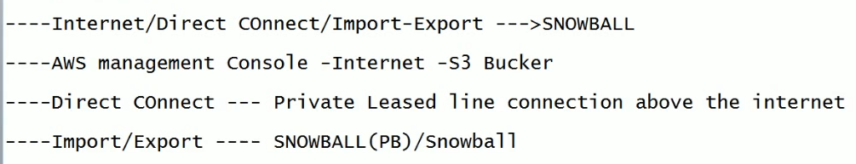

**Bucket:**

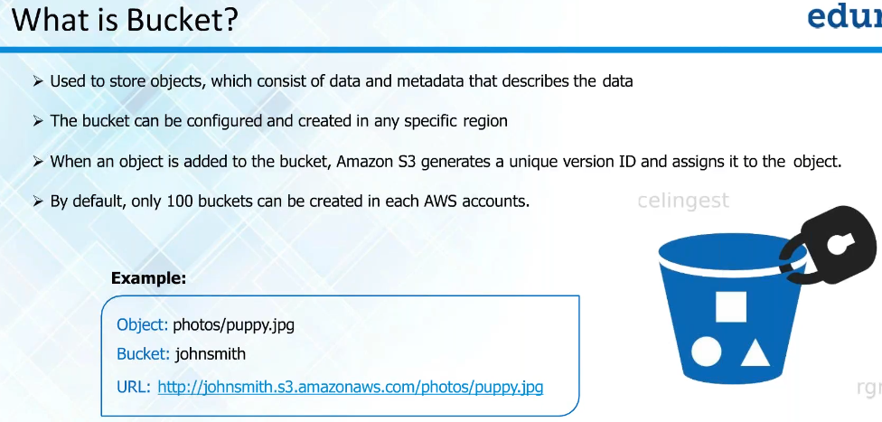

* It is nothing but a folder where we store our objects
* By default, 100 buckets allowed in each AWS account. If we want, we can ask amazon to increase
* If we want to do any kind of installation, we need block storage

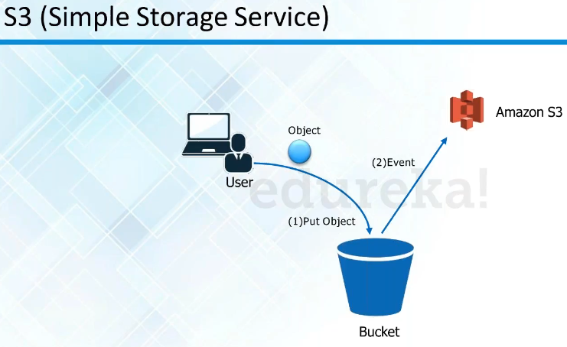

* We need to give a globally unique name to a bucket.
* S3 is a global service. But buckets are defined in region level.

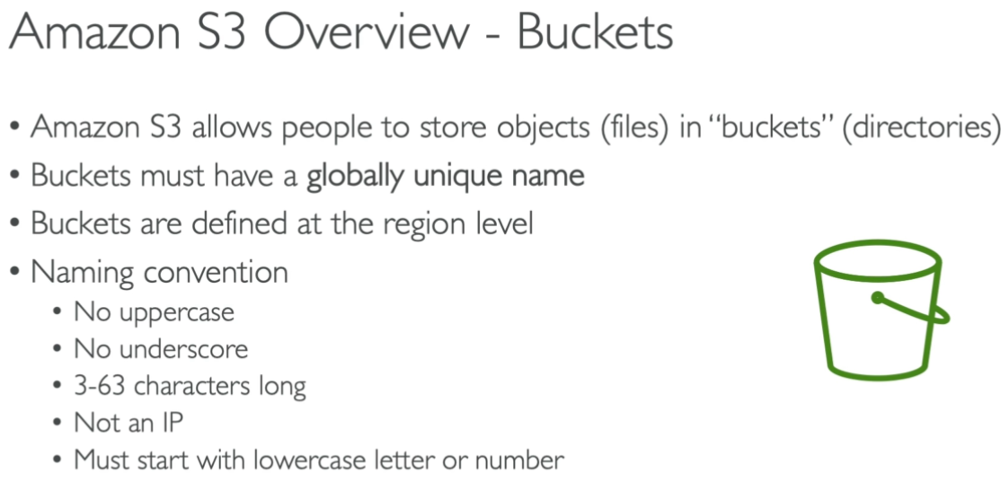

**Objects:**

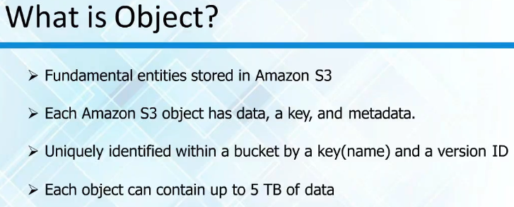

* We store objects in it
* Each object can be up to 5 TB data
* We will be storing the objects in bucket

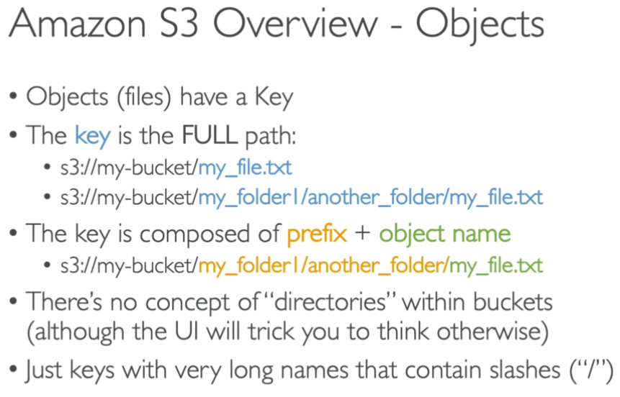

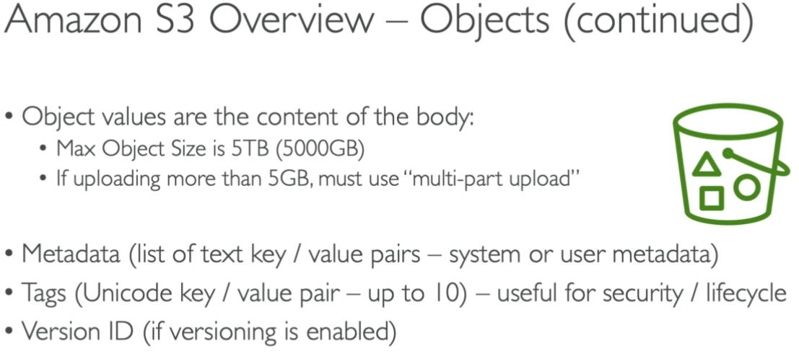

**Types of S3:**

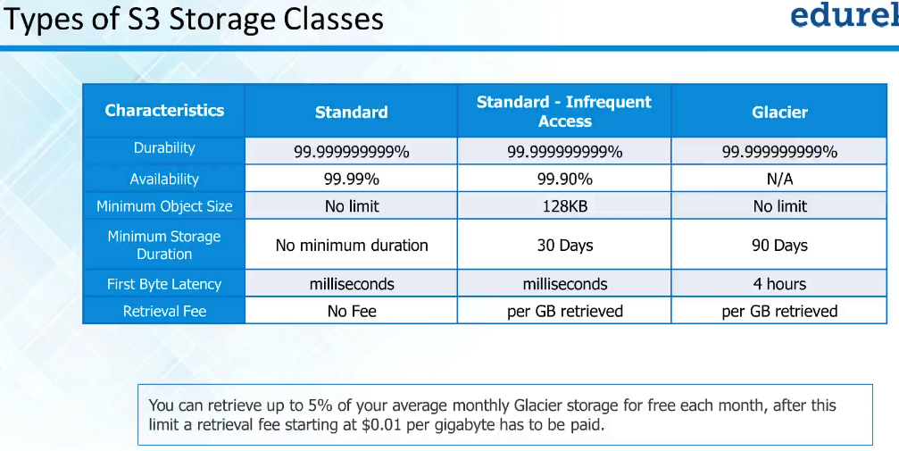

* If we are not specifying which type of storage we need, it takes storage type
* Durability means how long the files will be stored there without getting crashed. We call them as 11 9s. it is 11 9’s durability
* Availability is how long the file will be there to access
* There is no fee for standard to retrieve the data
* In glacier, if want to read the data, it might take up to 4 hrs time. This kind of storage used for archival
* It is like a lifecycle. Example, we create a file in standard and after some days we found that we are not accessing the file much and we want to move it infrequent access. Then we can move to archival

**RRS:**

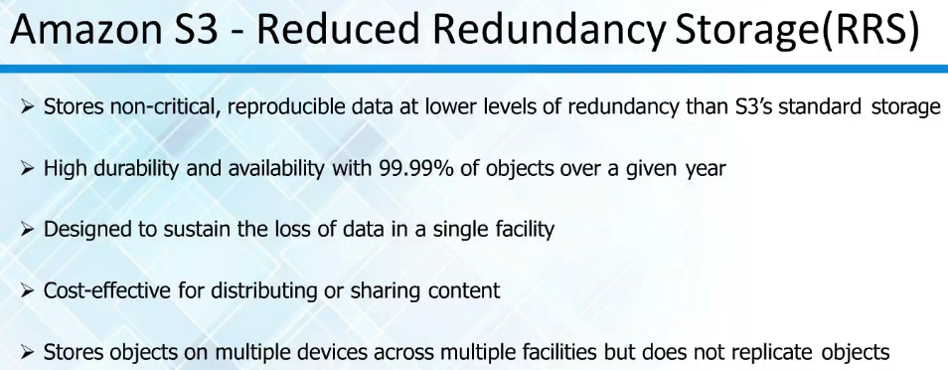

* In standard, there will be multiple copies stored
* But in RRS, very few disks will be managing the data. If it is non-critical data, we can go for RRS